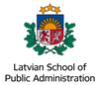
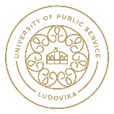
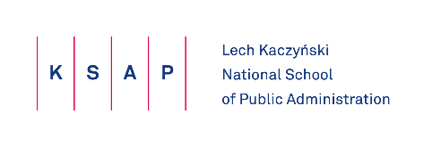

SYNERGIA
Access criteria

Access criteria for Participants (institutions) from Partners countries:
Institutions of public administration at the central or provincial levels, as well as state-run offices/agencies.
It means that the Project Participants in Partners countries should be:
- institutions of the central or provincial administrations of Central and Eastern European Countries,
- units subordinated to or supervised by the aforesaid institutions of the central or provincial administrations of the CEECs.

Access criteria for Representatives of the Participant (institution):
- a potential Representative has at least a Master’s degree or equivalent (in possession of a copy of the Diploma confirming completion of Master’s Studies or the equivalent);
- a potential Representative has at least five years of professional experience, including one year of experience in a senior managerial or coordinating position;
- a potential Representative knows English at a level allowing for participation in the Project (B2 level needed - certificate needed or verification by Partner institution at the recruitment stage);
- a potential Representative holds of the managerial or team-coordinating posts, at present:
1) at central level (Secretaries or Under-Secretaries of State, or Heads or Deputy Heads of Central Offices, Directors-General, Department or Office Heads or Deputy Heads, Chief Accountants, and other post-holders equivalent to these referred to);
2) at provincial level (e.g. as Provincial Governors or Deputy Governors, DGs and Directors or Deputy Directors of field offices, heads of sections or other organisational units at institutions or their deputies, Chief Accountants, and other post-holders equivalent to those referred to).

- a potential Representative undertakes to engage in the preparation of a report following completed participation in the Education and Cooperation Programme;
- a potential Representative has the consent of the Director-General/Head of office to take part in the project;
- each Partner Country is eligible to propose up to 10 Representatives for each edition of the Education and Cooperation Programme.

Substantive criteria
The potential Representative will justify the need to participate in the Project (via information in the application):
1. describing the origin of a management challenge in an area of management corresponding with Project subject matter, and presenting tools used in diagnosing the given situation;
2. describing the aforementioned challenge in terms of its being an area in which implementation work will be undertaken;
3. describing barriers impeding (or likely to impede) the implementation work intended to bring about change in the sphere of the management challenge identified.

Formal criteria
The application is to be:
- submitted on time,
- submitted in English where Participants are from outside Poland,
- accompanied by:
- a confirmation of employment of the potential Representative in a managerial or coordinating position in the applicant institution;
- a cover letter in which proposed Representative of the Participant institution is presented, with an indication of his/her strengths and a brief description of his/her motivation to take part in the Project;
- a commitment that potential Representative will participate in the Education and Cooperation Programme and develop (in cooperation with others taking part in the Project) recommendations for institution in areas covered by the Project are concerned;
- a commitment that potential Representative will submit a report on completing participation in the Education and Cooperation Programme, which will present conclusions in regard to his/her involvement, as well as a plan via which acquired knowledge and competences can be deployed in the delegating institution;
- developing a good practice implementation project for the delegating institution - only if the delegating institution will participate in the implementation stage;
- the consent of the Director-General/Head to the participation in the Project of the potential Representative;
- a commitment on the part of the Director-General/Head of institution ensuring support of participation of delegated Representatives in the Project.

